# 📘 1. JavaScript DOM Selection

## 🔹 What is DOM?

* The **DOM (Document Object Model)** represents the structure of your HTML page as a tree.
* JavaScript uses the DOM to **select**, **read**, and **manipulate** elements on the page.

## 🔹 DOM Selection Methods Summary

| Method | Selector Type | Returns | Live? | Use Case |
| --- | --- | --- | --- | --- |
| getElementById() | id | Single element/null | ❌ No | When selecting **one unique element** |
| getElementsByClassName() | .class | HTMLCollection | ✅ Yes | To select **all elements** with a class |
| querySelector() | CSS selector | First match/null | ❌ No | For **one element** using any CSS selector |
| querySelectorAll() | CSS selector | NodeList (all) | ❌ No | To select **all matches** using CSS selectors |

## 🔹 1. getElementById("id")

* ✅ Selects **1 element** by ID
* ✅ Returns a **single element** or null
* <p id="title">Hello</p>
* let title = document.getElementById("title");
* title.style.color = "green";

## 🔹 2. getElementsByClassName("class")

* ✅ Selects **all elements** with a class
* ✅ Returns an **HTMLCollection** (live)
* <p class="note">Note 1</p>
* <p class="note">Note 2</p>
* let notes = document.getElementsByClassName("note");
* notes[1].style.color = "blue";

## 🔹 3. querySelector("selector")

* ✅ Selects the **first matching** element
* ✅ Works with #id, .class, tag, etc.
* ✅ Returns **single element** or null
* let title = document.querySelector("#title");
* let note = document.querySelector(".note");

## 🔹 4. querySelectorAll("selector")

* ✅ Selects **all elements** matching a CSS selector
* ✅ Returns a **NodeList** (not live)
* let items = document.querySelectorAll(".item");
* items[0].style.color = "red";
* ✅ Returns: **NodeList** (a list of all matching elements)
* ✅ Use: To get **multiple elements** using **CSS selectors**
* ✅ Not live (does **not auto-update** when DOM changes)

### 🧠 Example:

<p class="item">Item 1</p>

<p class="item">Item 2</p>

let items = document.querySelectorAll(".item");

console.log(items.length);     // 2

items[0].style.color = "red";  // Changes first item text to red

### 

### ⚡ Quick Recap Table:

| Method | Selector Type | Returns | Live? |
| --- | --- | --- | --- |
| getElementsByClassName | Class name | HTMLCollection | ✅ Yes |
| getElementById | ID only | Single Element/null | ❌ No |
| querySelector | CSS selector | First Match/null | ❌ No |
| querySelectorAll | CSS selector | NodeList (all) | ❌ No |

# 📘 2. **innerText** vs **textContent** vs **innerHTML** in JavaScript

| Feature | innerText | textContent | innerHTML |
| --- | --- | --- | --- |
| 📋 Returns | Visible **text** only (no tags) | **All text**, incl. hidden | HTML + text |
| 👁️ Visibility | Respects CSS (display: none, etc.) | Ignores CSS | Shows raw HTML |
| 🧹 Whitespace | Cleaned up | Preserved | Preserved |

### 📌 Quick Examples:

    <h1 class="test">Hello this is lambodar <span style="display: none;">this is test text</span></h1>

test.innerText

'Hello this is lambodar'

test.textContent

'Hello this is lambodar this is test text'

test.innerHTML

'Hello this is lambodar <span style="display: none;">this is test text</span>'

### ✅ Best Use:

* Use innerText → for what's shown to users.
* Use textContent → for **pure text processing**.
* Use innerHTML → for **inserting/retrieving HTML**.

# 📘 3. getAttribute() vs setAttribute() in JavaScript

### getAttribute() vs setAttribute() in JavaScript

| Feature | getAttribute() | setAttribute() |
| --- | --- | --- |
| 📖 Purpose | Reads an attribute’s value | Sets/updates an attribute’s value |
| 🎯 Works On | Any HTML attribute (like href, id) | Any valid HTML attribute |
| 🧠 Use Case | Get custom or built-in attr values | Add/change attributes dynamically |
| ⚠️ Note | Doesn’t read **properties** like el.value | Doesn’t affect JS **properties** directly |

### 📌 Syntax:

element.getAttribute("attrName")

element.setAttribute("attrName", "value")

### ✅ Example:

<a id="link" href="https://example.com" target="_blank">Click me</a>

const link = document.getElementById("link");

link.getAttribute("href");         // 🔎 "https://example.com"

link.setAttribute("href", "#");    // 🛠️ Changes href to "#"

link.setAttribute("title", "Go!"); // 🆕 Adds title attribute

### ❗ Common Attributes You Can Access:

* href, src, alt, id, class, type, name, value, title, data-* attributes

## 🔧 Ways to Select Element + Use getAttribute() and setAttribute()

| Selector Method | Get Attribute Example | Set Attribute Example |
| --- | --- | --- |
| getElementById() | document.getElementById("myId").getAttribute("href") | document.getElementById("myId").setAttribute("href", "#") |
| getElementsByClassName() | document.getElementsByClassName("btn")[0].getAttribute("data-value") | document.getElementsByClassName("btn")[0].setAttribute("data-value", "123") |
| getElementsByTagName() | document.getElementsByTagName("img")[0].getAttribute("src") | document.getElementsByTagName("img")[0].setAttribute("alt", "Image") |
| querySelector() | document.querySelector(".card").getAttribute("title") | document.querySelector(".card").setAttribute("title", "Card Title") |
| querySelectorAll() | document.querySelectorAll("p")[0].getAttribute("id") | document.querySelectorAll("p")[0].setAttribute("id", "para1") |

### ✅ Reminder:

* .getAttribute("name") → gets the value
* .setAttribute("name", "value") → sets or updates the value

# 📘 4. How to Apply Styles in JavaScript

### ✅ 1. **Using .style.property**

element.style.color = "red";

element.style.backgroundColor = "yellow";

✔️ Directly applies inline styles

### ✅ 2. **Using .style.cssText** (set multiple at once)

element.style.cssText = "color: white; background: black; padding: 10px;";

### ✅ 3. **Using setAttribute("style", "...")**

element.setAttribute("style", "font-size: 18px; border: 1px solid gray;");

### ✅ 4. **Using classList.add() / remove() / toggle()**

*(Best for reusable styles via CSS classes)*

element.classList.add("active");

element.classList.remove("hidden");

element.classList.toggle("dark-mode");

### ✅ 5. **Using ES6+ Loop + Arrow Functions**

// Apply same style to multiple elements

document.querySelectorAll(".box").forEach(el => {

  el.style.borderRadius = "10px";

  el.style.boxShadow = "0 0 10px rgba(0,0,0,0.2)";});

### 

### ✅ 6. **Using Object.assign()** (for bulk inline styles)

Object.assign(element.style, {

    color: "blue",

    fontWeight: "bold",

    marginTop: "20px"

  });

## ⚡ Most Used Style Properties in Real Projects:

* color, backgroundColor
* fontSize, fontWeight, textAlign
* margin, padding, border, borderRadius
* display, flex, grid
* width, height, position, zIndex

## 🎁 Bonus Tip — Toggle Dark Mode Example (ES6):

const toggle = document.getElementById("toggleTheme");

toggle.addEventListener("click", () => {

  document.body.classList.toggle("dark-mode");

});

**classList.add()**, **remove()**, **toggle()**, and **contains()**, explained clearly with an example:

### 💡 Working with classList in JavaScript

The classList property allows you to **add**, **remove**, **toggle**, and **check** CSS classes on an HTML element.

### ✅ **1. Add a Class**

element.classList.add('my-class');

Adds the class my-class to the element.

### ✅ **2. Remove a Class**

element.classList.remove('my-class');

Removes the class my-class from the element.

### ✅ **3. Toggle a Class**

element.classList.toggle('my-class');

* If the class is **present**, it will be **removed**.
* If the class is **not present**, it will be **added**.

### ✅ **4. Check if a Class Exists**

element.classList.contains('my-class');

Returns true if the element has the class, otherwise false.

<div id="box">Hello</div>

<button id="btn">Click Me</button>

const box = document.getElementById('box');

const btn = document.getElementById('btn');

btn.addEventListener('click', () => {

  // Toggle the class

  box.classList.toggle('active');

  // Check if class exists

  if (box.classList.contains('active')) {

    console.log('Box is active!');

  } else {

    console.log('Box is not active.');

  }

});

# 📘 5. Access Parent Sibling & Children Elements

New trick to select element for every time we have to write id,class and then select element so easy way for testing your code go to chrome dev tool  
html code > hover on element >right click copy js path   
  
then just create var and pase this js path as selected element it will get selected and stores in var

### ✅ 1. **Parent Element**

* element.parentElement
* 🔄 Goes **one level up**
* ❗ Ignores text nodes (safe to use)

**Example:**

 <div class="cl">

        <h3>"hello world"</h3>

        <h3>"hello world"</h3>

        <h3>"hello world"</h3>

    </div>

----------------------------------------------------------------------------

const myel=document.querySelector('h3')

--myel

<h3>"hello world"</h3>

-- myel.parentElement

<div class="cl">…</div>

-- myel.parentElement.parentElement

<body>…</body>

-- myel.parentElement.parentElement.parentElement

<html lang="en"><head>…</head><body>…</body></html>

### ✅ 2. **Children Elements**

element.children

* Returns **HTMLCollection** of child elements (no text nodes)
* element.firstElementChild
* element.lastElementChild

 <div class="cl">

        <h3>"hello world"</h3>

        <h3>"hello world"</h3>

        <h3>"hello world"</h3>

    </div>

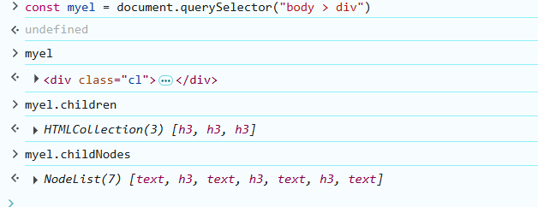----------------------------------------------------------------------------

### ✅ 3. **Sibling Elements**

element.previousElementSibling  
element.nextElementSibling

* Accesses elements **beside** the current one

**Example:**        <h3>"hello world"</h3>

        <h3>"hello world"</h3>

        <h3>"hello world"</h3>

    </div>

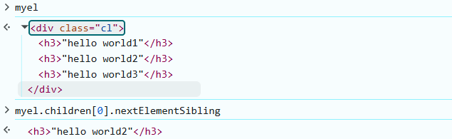

# 📘 6. Node vs Element — What's the Difference?

✅ Node ( General Building Block)

* A **generic** type — everything in the DOM is a Node.
* Types of nodes:
  + Element node (<div>, <p>)
  + Text node ("Hello")
  + Comment node (<!-- comment -->)
  + Document node (document)
  + etc.

**Example:**

document.body.childNodes;  
// Returns ALL nodes: elements, text, comments, etc.

✅ Element ( Specific Type of Node)

* A **node that is an HTML element**
* Subtype of Node
* Only represents tags like <div>, <p>, <ul>, etc.

**Example:**

document.body.children;  
// Returns ONLY element nodes (ignores text/comments)

🧠 Key Differences:

| Feature | Node | Element |
| --- | --- | --- |
| Type | General (includes text, etc.) | Specific (just HTML tags) |
| Example Nodes | Element, Text, Comment | <div>, <h1>, <ul>, etc. |
| Common Accessors | .childNodes, .firstChild | .children, .firstElementChild |
| Useful When | Parsing *everything* in DOM | Working with HTML *structure* |

✅ Quick Code Comparison:

// Includes text, comment, etc.  
console.log(document.body.childNodes);   
  
// Only actual HTML elements  
console.log(document.body.children);

# 📘 7. apendChild() & cloneNode() in JavaScript

**[project link](https://github.com/Lambodar2001/FrontEndDev2025/tree/main/Ep2.%20DOM1-append%2C%20clone%2C%20append%20child/code)**

### ✅ 1. appendChild()

Adds a node as the **last child** of a parent element. Its like push on webpage anything created with js

parent.appendChild(child);

**Example:**

  <div class="cl1">

        <h3>"hello this is part of class1"</h3>

    </div>

    <div class="cl2">

        <h3>"hello this is part of class2"</h3>

    </div>

    <h3 class="testText">Hi this is test text </h3>

const class1= document.querySelector(".cl1")

const class2= document.querySelector(".cl2")

const testText= document.querySelector('.testText')

class1.appendChild(testText)

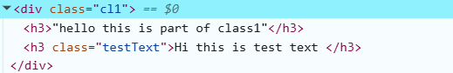

Example 2:

const list = document.querySelector("ul");

const newItem = document.createElement("li");

newItem.textContent = "New Item";

list.appendChild(newItem); // Adds <li> to end of <ul>

### 

### ✅ 2. element.cloneNode()

Creates a **copy of a node** (shallow or deep).

element.cloneNode(true);  // Deep clone (with children)

element.cloneNode(false); // Shallow clone (just the element)

**Example:**

const card = document.querySelector(".card");

const copy = card.cloneNode(true);

document.body.appendChild(copy); // Add the cloned card to body

### 📌 Common Use:

const node = document.getElementById("box");

const clone = node.cloneNode(true);  // Clone whole element

document.body.appendChild(clone);    // Insert at end of body

### 

### 🧠 Key Points:

| Method | Purpose | Notes |
| --- | --- | --- |
| appendChild() | Insert a node at the end | Moves existing or new node |
| cloneNode() | Clone element (optionally deep) | Doesn’t insert — needs append |

   <div class="container">

   <div class="card1 cardMain">c1</div>

   <div class="card2 cardMain">c2</div>

   <div class="card3 cardMain">c3</div>

   </div>

const selectCard= document.querySelector(".card1")

const container = document.querySelector(".container")

container.appendChild(selectCard.cloneNode(true))

<div class="card1 cardMain">c1</div>

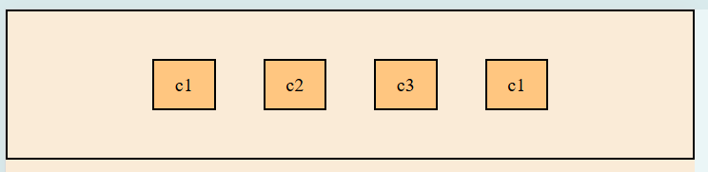

# 📘 Project on use of append ,clone node, innerText , set Attribute

Project1: Using a loop make 100 cards with inner text 1 to 100  
  
html:

    <div class="container">

        <div class="card1 cardMain">1</div>

        <div class="card2 cardMain">2</div>

        <div class="card3 cardMain">3</div>

    </div>

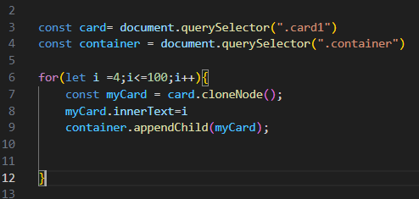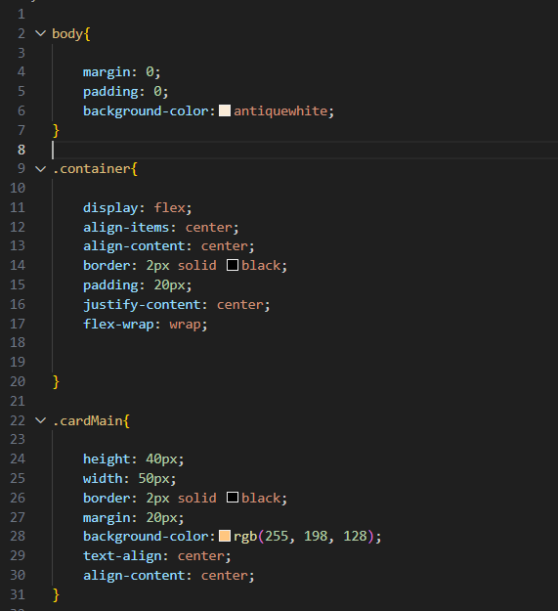Css:  
  
  
  
  
  
  
  
  
  
  
  
  
  
  
  
  
  
  
  
  
  
  
  
  
Project1: Using a loop make 100 sticker pokemon sprite api  
आपल्याला डायनामिकल इलेमेंट क्रिएट करून append करायचा आहे सो डायनामी केली क्रिएट करण्यासाठी आपण लिंक ला manipulate करणार इमेज लिंक ला

    const myCard = card.cloneNode();

याला आपल्याला लूप च्या अंत मध्येच declare करावा लागणार कारण बाहेर जर केला तर तो एकदाच कॉपी होणार.   
आपलीला नवीन कॉपी आणि append होणाऱ्या एलिमेंट मध्ये text add काराईचे आहे सो आपण innertext use केला

    <h3>Learning appendChild, cloneNode , setAttribute , Create element</h3>

    <div class="container">

        <img id="img" src="https://raw.githubusercontent.com/PokeAPI/sprites/refs/heads/master/sprites/pokemon/10.png" alt="">

    </div>

const imgUrl= document.querySelector("#img")

const container = document.querySelector(".container")

for(let i =4;i<=100;i++){

    let newImgUrl = imgUrl.cloneNode()

    newImgUrl.setAttribute("src", `https://raw.githubusercontent.com/PokeAPI/sprites/refs/heads/master/sprites/pokemon/${i}.png`);

    container.appendChild(newImgUrl)

}

Concept :   
  
setAttribute( src , link)

setAttribute( href , link)

# 📘 7. Element creation using createEelement()

[**project link**](https://github.com/Lambodar2001/FrontEndDev2025/tree/main/Ep3.%20DOM2-%20creating%20an%20element/code)

### ✅ 1. **Create an Element**

let element = document.createElement("tagName");

•   tagName can be: "div", "p", "h1", "img", etc.

let newDiv = document.createElement("div");

### ✅ 2. **Add Content (Text)**

element.textContent = "Hello World!";

newDiv.textContent = "I am a new div!";

### ✅ 3. **Add Attributes / Classes / IDs**

element.id = "myId";

element.className = "myClass";

element.setAttribute("title", "tooltip");

newDiv.id = "box1";

newDiv.className = "container";

### ✅ 4. **Append to the Page**

document.body.appendChild(element);

document.body.appendChild(newDiv);

### ✅ 5. **Create and Append Inside Another Element**

let container = document.getElementById("container");

container.appendChild(newDiv);

## 🧪 Simple Example (HTML + JS)

html:  
  <h3>Learning appendChild, cloneNode , setAttribute , Create element</h3>

    <div class="container">

    </div>

Js

const newEl = document.createElement("img")

newEl.src="https://famezip.com/wp-content/uploads/2024/06/arshiya-sharma.png"

newEl.style.cssText="height:500px;width:400px"

const container=document.querySelector(".container")

container.append(newEl)

# 📘 Project on use of createElement

Project1: Using a loop make 100 sticker and another p tag which val changes form 1-100

 <div class="block">

            <img src="https://raw.githubusercontent.com/PokeAPI/sprites/refs/heads/master/sprites/pokemon/10.png" alt="">

            <p>this is 1</p>

        </div>

Now create this reference is img in js

const block= document.querySelector('.container')

for(let i =1;i<=100;i++){

    const newImg = document.createElement('img')

    newImg.style.cssText="height:100px; width: 100px;"

    const text= document.createElement('p')

    newImg.src= `https://raw.githubusercontent.com/PokeAPI/sprites/refs/heads/master/sprites/pokemon/${i}.png`

    text.innerText=i

    block.append(newImg, text)

}  
  
HTML:

 <div class="container">

    </div>

If you want to every time clone or created new el append then always keep this creation or clone in loop

## How to Remove Elements in JavaScript

### ✅ 1. Remove HTML Element from the DOM

#### ✅ element.remove()

✔️ Most modern way (ES6+)  
✔️ Directly removes the element

js

CopyEdit

const elem = document.getElementById('myDiv');

elem.remove();

### ✅ Remove all child elements

js

CopyEdit

const parent = document.getElementById('container');

parent.innerHTML = ''; // clears all content

## ⚠️ Good to Know

* Use remove() only if you're sure the element exists.
* Always check for null before removing:

js

CopyEdit

const el = document.getElementById('something');

if (el) el.remove();